**ESE Team 6 Bug Hunting**

<http://localhost:8080/orders/add>

* Not always possible to select a client
* Don’t matters what is false, always the same error
* Whitelabel error page when entering a 5 digit long year like 20160

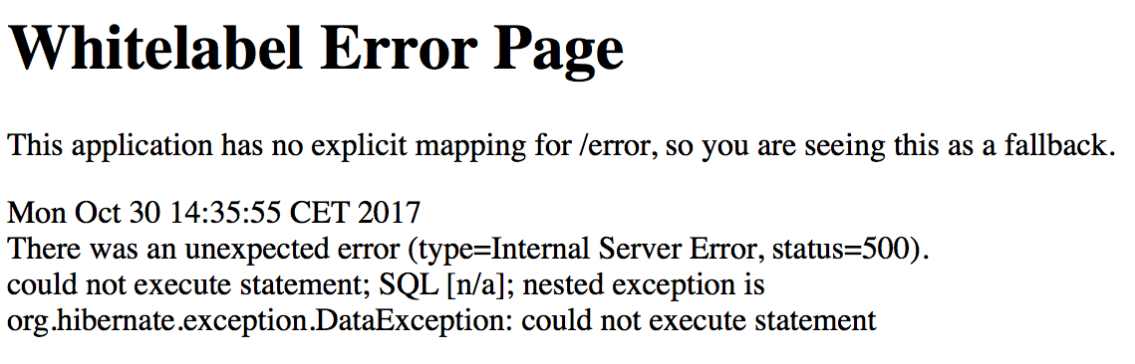

<http://localhost:8080/orders/>

* We have added an order for 2016
* We could create an order with the date:

2017-10-3bhddddd 🡪 result: 2017-10-03

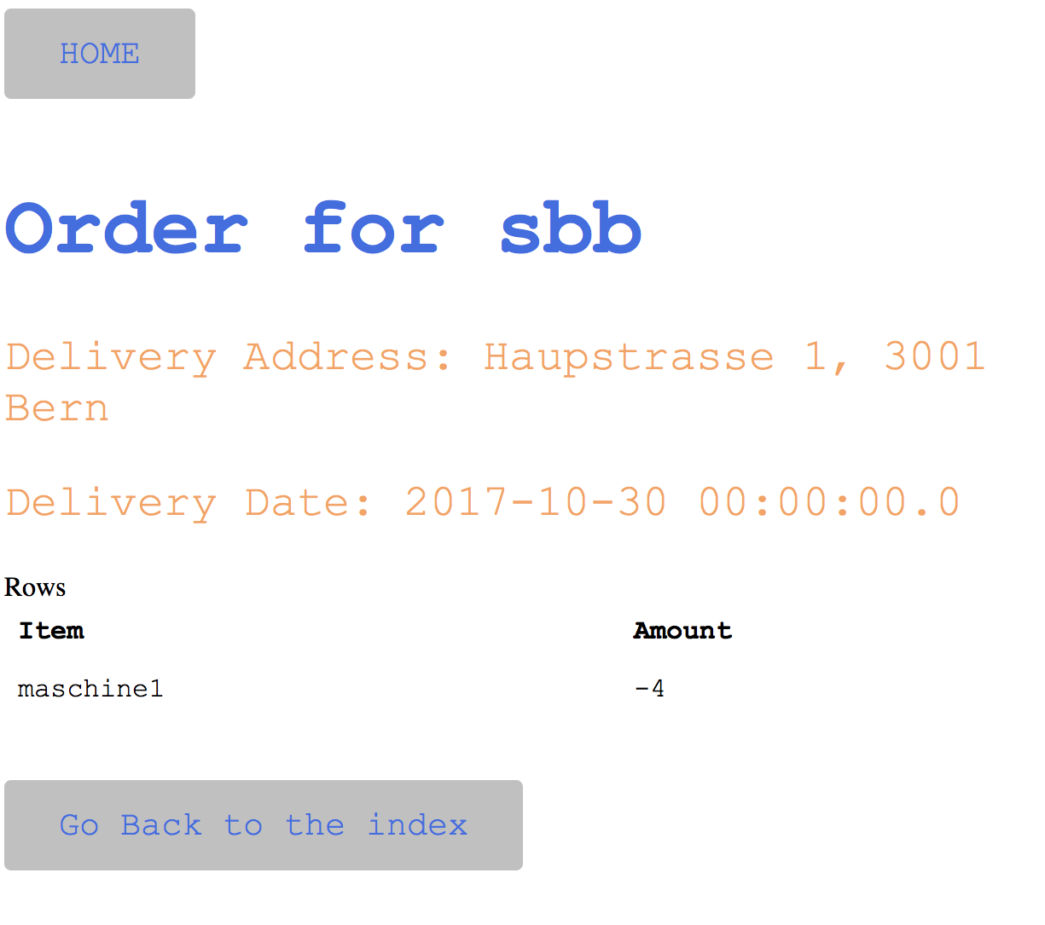

<http://localhost:8080/hello>

* Create some sample data is not working (it doesn’t do anything at all)

<http://localhost:8080/customer/add>

* You can not add a random address (You can just choose Hauptstrasse 1 bis 6 Bern)

<http://localhost:8080/address/add>

* After you created a new address, the page shows all addresses = new address (the existing addresses are not showed and the new address is afterwards not showed)

<http://localhost:8080/login?error>

* Could not sign in as user from database (just as user: user and password: password

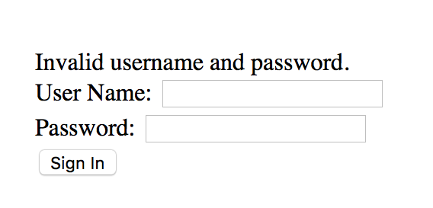

<http://localhost:8080>

* When you logged in once and log out and log in again this site is comming between the login page and the home page

